About Page

Definition
# Source: AI Source: Provided by: [Data Path: Persons Table -> ID Column: 1, Name_En Column: Motasem Essam] -> From: [Chatgpt (GPT‑5 Mini)] on [2/12/2026]
An About Page is a web page that gives information about a person, company, organization, or website. It tells visitors who you are, what you do, and your story.

Simple Definition
# Source: AI Source: Provided by: [Data Path: Persons Table -> ID Column: 1, Name_En Column: Motasem Essam] -> From: [Chatgpt (GPT‑5 Mini)] on [2/12/2026]
About Page = a page that explains who you are and what your website or business is about.

What an About Page Usually Includes
# Source: AI Source: Provided by: [Data Path: Persons Table -> ID Column: 1, Name_En Column: Motasem Essam] -> From: [Chatgpt (GPT‑5 Mini)] on [2/12/2026]
- Introduction – who you are (person, company, or organization)
- Story / Background – how you started, history, or journey
- Mission & Vision – goals, values, or purpose
- Team (optional) – key people or members
- Achievements (optional) – awards, milestones, experience

Purpose of an About Page
# Source: AI Source: Provided by: [Data Path: Persons Table -> ID Column: 1, Name_En Column: Motasem Essam] -> From: [Chatgpt (GPT‑5 Mini)] on [2/12/2026]
- Build trust and credibility
- Help visitors understand who you are
- Show your experience, values, and goals
- Create a personal or professional connection with users

Examples
# Source: AI Source: Provided by: [Data Path: Persons Table -> ID Column: 1, Name_En Column: Motasem Essam] -> From: [Chatgpt (GPT‑5 Mini)] on [2/12/2026]
- Personal website → About the person, skills, and journey
- Business website → Company history, mission, and team
- Organization website → Goals, purpose, and activities

Difference Between About Page and Home Page
# Source: AI Source: Provided by: [Data Path: Persons Table -> ID Column: 1, Name_En Column: Motasem Essam] -> From: [Chatgpt (GPT‑5 Mini)] on [2/12/2026]
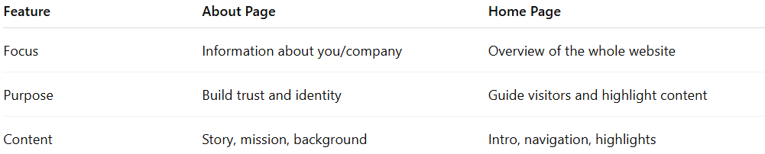
Feature | About Page | Home Page
Focus | Information about you/company | Overview of the whole website
Purpose | Build trust and identity | Guide visitors and highlight content
Content | Story, mission, background | Intro, navigation, highlights

